Week 1:

By Aman Deep Singh

Roll no: RA2311003011710

**1. Even or Odd Number Check:**

Write a program that asks the user to enter a number. Use an if statement to check if the number  is even or odd:

• If the number divided by 2 has a remainder of 0 (even number), print "The number is  even."

• Otherwise (odd number), print "The number is odd."

import java.util.Scanner;

public class evenorodd {

    public static *void* main(String[] *args*) {

        Scanner sc = new Scanner(System.in);

        System.out.println("Enter a number: ");

*int* num = sc.nextInt();

        if (num % 2 == 0){

            System.out.println("The number is even");

        }

        else {

            System.out.println("The number is odd");

            }

            sc.close();

        }

}

Output:

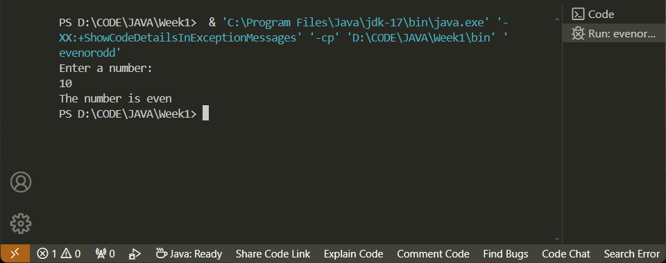

**2. Age Verification:**

Create a program that asks the user for their age. Use an if statement to determine eligibility to vote:

• If the user's age is 18 or above, print "You are eligible to vote."

• Otherwise, print "You are not eligible to vote."

import java.util.Scanner;

public class ageverification {

    public static *void* main(String[] *args*) {

        Scanner sc = new Scanner(System.in);

        System.out.println("Enter your age: ");

*int* age = sc.nextInt();

        if (age >= 18) {

            System.out.println("You are eligible to vote");

            } else {

                System.out.println("You are not eligible to vote");

                }

                sc.close();

}

}

Output:

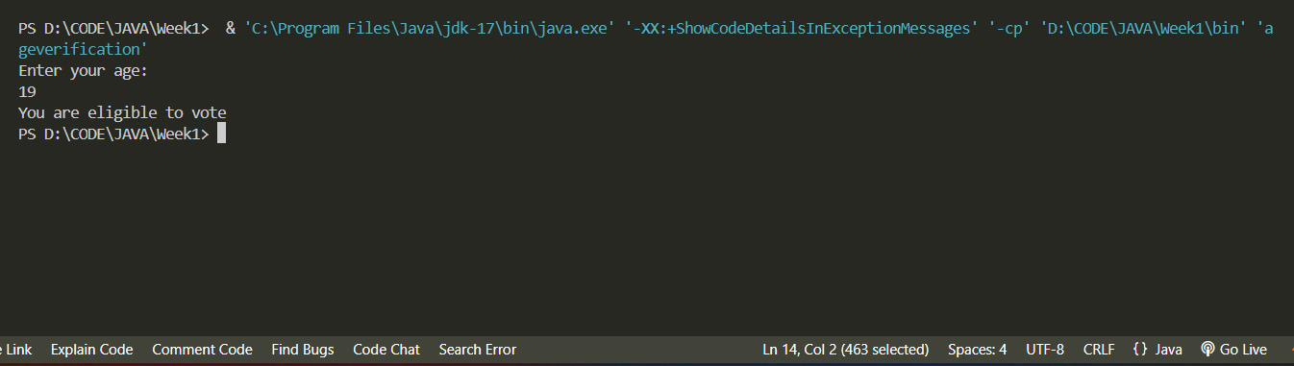

**3. Vending Machine (Single Choice):**

Simulate a simple vending machine with two options:

• Display a message "Press 1 for juice or 2 for soda."

• Ask the user for their choice using nextInt() method.

• Use an if statement to check the choice:

o If 1, print "Dispensing juice."

o If 2, print "Dispensing soda."

o Otherwise, print "Invalid choice."

import java.util.Scanner;

public class VendingMachine {

    public static *void* main(String[] *args*) {

        Scanner sc = new Scanner(System.in);

        System.out.println("Press 1 for juice or 2 for soda:");

*int* choice = sc.nextInt();

        if(choice == 1) {

            System.out.println("Dispensing Juice");

        }

        else if(choice == 2) {

            System.out.println("Dispensing Soda");

            }

        sc.close();

}

}

Output:

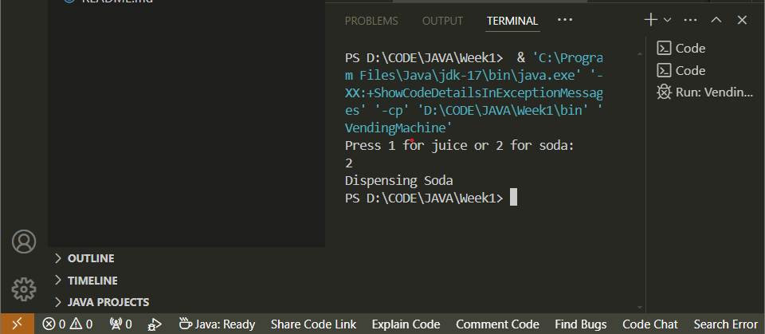

**4. Temperature Check:**

Write a program that asks the user for the current temperature. Use a series of if statements to  categorize the temperature:

• If the temperature is above 30 degrees Celsius, print "It's hot!"

• If the temperature is between 20 and 30 degrees Celsius, print "It's warm." • If the temperature is between 10 and 20 degrees Celsius, print "It's cool." • Otherwise, print "It's cold."

import java.util.Scanner;

public class temperaturecheck {

    public static *void* main(String[] *args*) {

        Scanner sc = new Scanner(System.in);

        System.out.println("Enter the temperature (celsius): ");

*int* temp = sc.nextInt();

        if (temp > 30) {

            System.out.println("It's hot!");

            } else if (temp > 10 && temp < 20) {

                System.out.println("It's cool");

                } else if (temp > 20 && temp < 30) {

                    System.out.println("It's warm");

                    } else {

                        System.out.println("It's cold");

                        }

                        sc.close();

}

}

Output:

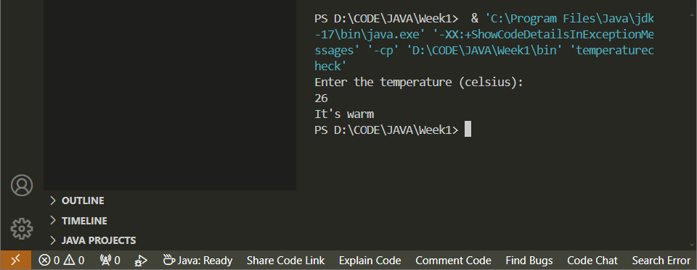

**5. Positive, Negative, or Zero:**

Create a program that asks the user to enter a number. Use an if statement with else if to  check the number's sign:

• If the number is greater than 0, print "The number is positive."

• If the number is less than 0, print "The number is negative."

• Otherwise, print "The number is zero."

import java.util.Scanner;

public class posnegze {

    public static *void* main(String[] *args*) {

        Scanner sc = new Scanner(System.in);

        System.out.println("Enter a number: ");

*int* num = sc.nextInt();

        if (num > 0) {

            System.out.println("The number is positive");

            } else if (num < 0) {

                System.out.println("The number is negative");

                } else {

                    System.out.println("The number is zero");

                    }

                    sc.close();

                    }

}

Output:

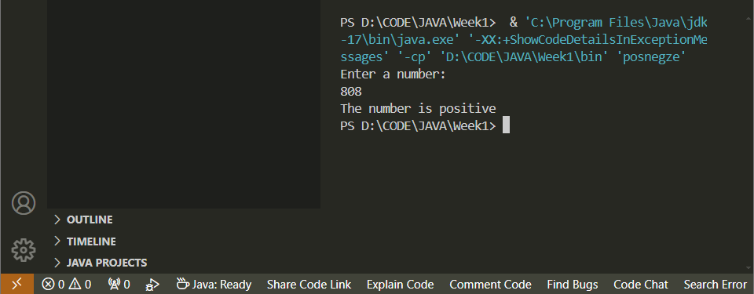

**6.Grading System:**

Write a program that asks the user for their exam score. Use a switch statement to assign a letter  grade based on the score:

• 90-100: "A" (Excellent)

• 80-89: "B" (Very Good)

• 70-79: "C" (Good)

• 60-69: "D" (Satisfactory)

• Below 60: "F" (Fail)

• You can add a default case for any invalid score input.

import java.util.Scanner;

public class gradingsystem {

    public static *void* main(String[] *args*) {

        Scanner sc = new Scanner(System.in);

        System.out.print("Enter your exam score: ");

        if (sc.hasNextInt()) {

*int* score = sc.nextInt();

            String grade;

            switch (score / 10) {

                case 10:

                case 9:

                    grade = "A (Excellent)";

                    break;

                case 8:

                    grade = "B (Very Good)";

                    break;

                case 7:

                    grade = "C (Good)";

                    break;

                case 6:

                    grade = "D (Satisfactory)";

                    break;

                default:

                    if (score >= 0 && score < 60) {

                        grade = "F (Fail)";

                    } else {

                        grade = "Invalid score";

                    }

                    break;

            }

            System.out.println("Your grade is: " + grade);

        } else {

            System.out.println("Invalid input. Please enter a valid integer score.");

        }

        sc.close();

    }

}

Output:

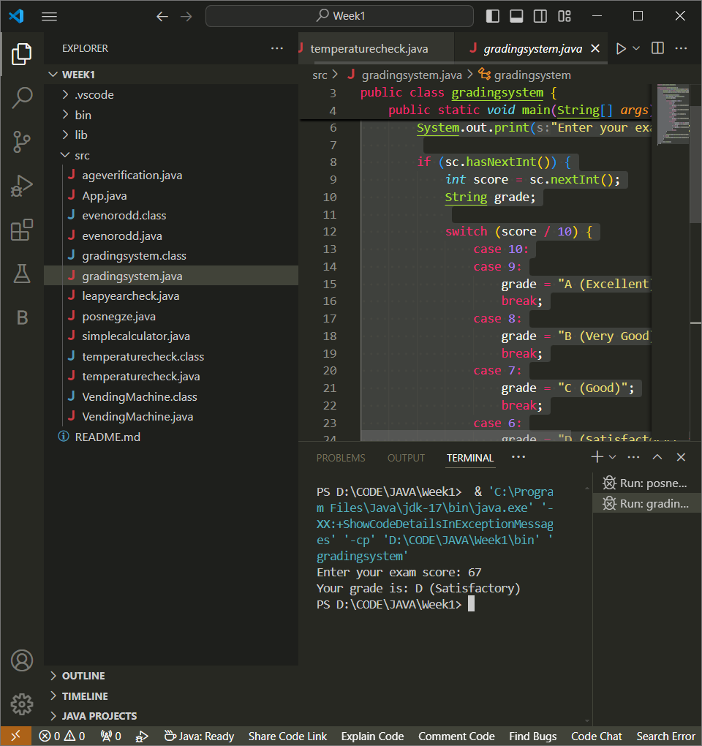

**7.Simple Calculator:**

Create a basic calculator that performs addition or subtraction based on user input:

• Display a message "Enter 1 for addition or 2 for subtraction."

• Ask the user for their choice using nextInt().

• Use an if statement to check the choice:

o If 1, ask for two numbers and print their sum.

o If 2, ask for two numbers and print their difference.

• Add an else statement to handle invalid choices.

import java.util.Scanner;

public class simplecalculator {

    public static *void* main(String[] *args*) {

        Scanner sc = new Scanner(System.in);

        System.out.println("Enter 1 for addition or 2 for subtraction:");

*int* choice = sc.nextInt();

        if (choice == 1) {

            System.out.println("Enter two numbers:");

*int* a = sc.nextInt();

*int* b = sc.nextInt();

            System.out.println("The sum is: " + (a + b));

            } else if (choice == 2) {

                System.out.println("Enter two numbers:");

*int* a = sc.nextInt();

*int* b = sc.nextInt();

                System.out.println("The difference is: " + (a - b));

                } else {

                    System.out.println("Invalid choice");

                    sc.close();

        }

}

}

Output:

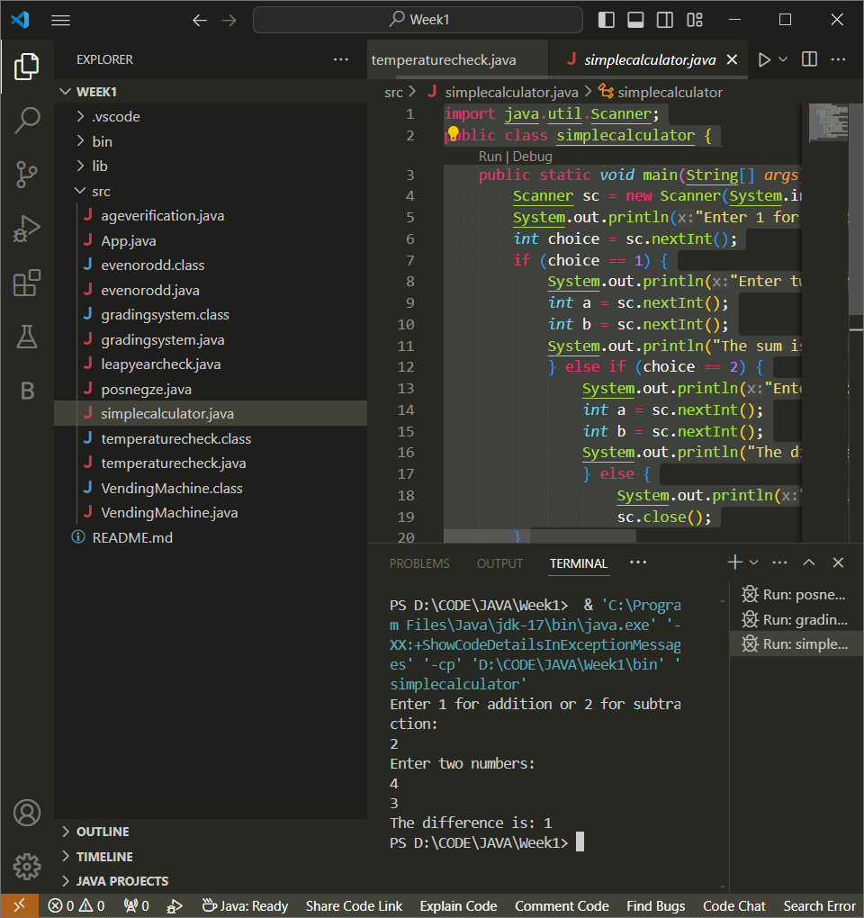

**8.Leap Year Check:**

Write a program to determine if a given year is a leap year. A leap year is a year divisible by 4,  but not by 100 unless also divisible by 400. Use a combination of if and else if statements to  achieve this:

• Ask the user for the year.

• Check divisibility by 4:

o If divisible by 4 but not by 100, it's a leap year.

o If divisible by 100, further check divisibility by 400.

▪ If divisible by 400, it's a leap year.

• Otherwise, it's not a leap year. (Use else statement)

import java.util.Scanner;

public class leapyearcheck {

    public static *void* main(String[] *args*) {

        Scanner sc = new Scanner(System.in);

        System.out.println("Enter the year:");

*int* year = sc.nextInt();

        if (year % 4 == 0) {

            if (year % 100 != 0) {

                System.out.println("The year is a leap year");

            } else if (year % 400 == 0) {

                System.out.println("The year is a leap year");

            } else {

                System.out.println("The year is not a leap year");

            }

        } else {

            System.out.println("The year is not a leap year");

        }

        sc.close();

    }

}

Output:

